# Lab 3. Exception Handling and Dynamic SQL

3.1: Modify the programs created in Lab2 to implement Exception Handling.

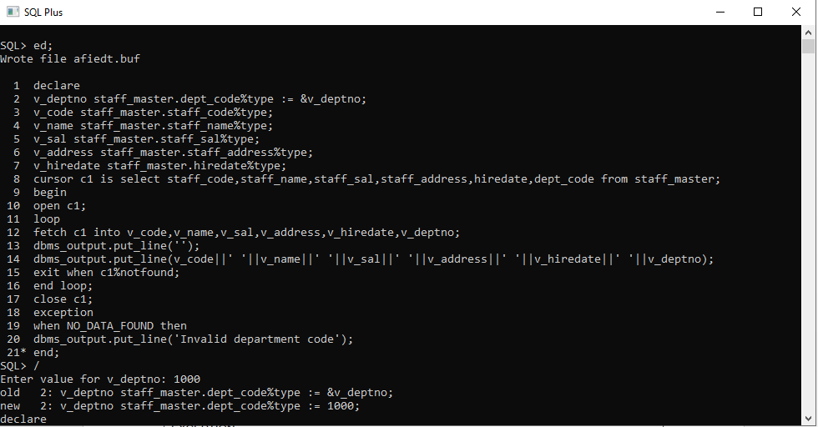

3.2 The following PL/SQL block attempts to calculate bonus of staff for a given

MGR_CODE. Bonus is to be considered as twice of salary. Though Exception Handling

has been implemented but block is unable to handle the same.

Debug and verify the current behavior to trace the problem.

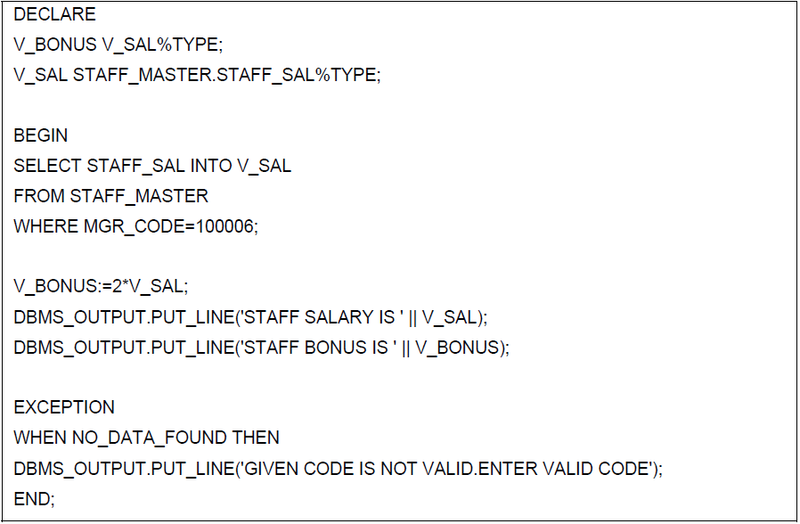

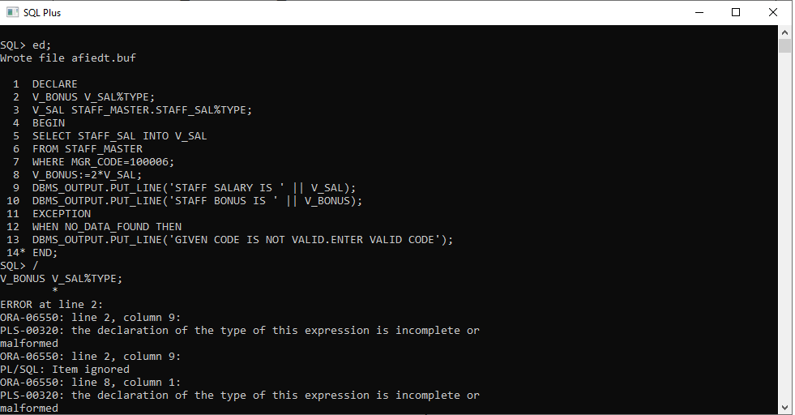

3.3 Rewrite the above block to achieve the requirement.

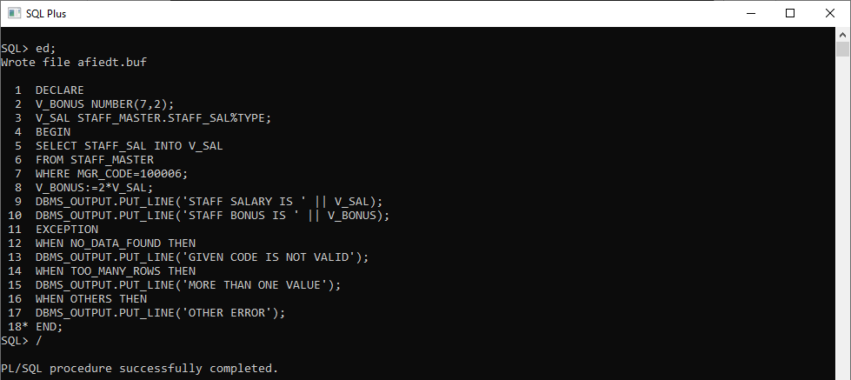

3.4 Predict the output of the following block ? What corrections would be needed to make it

more efficient?

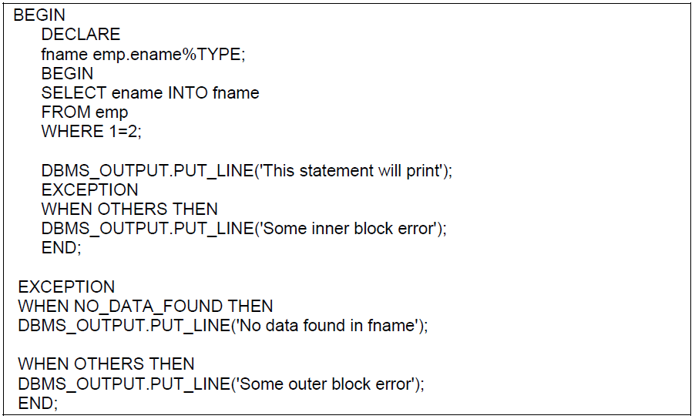

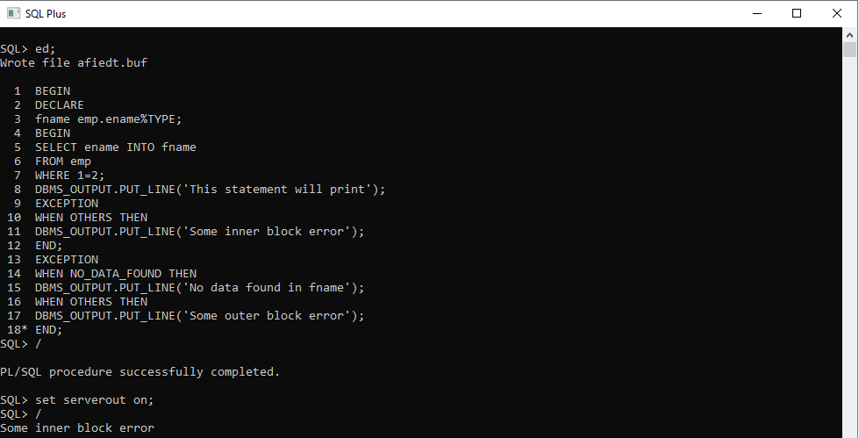

3.5 Debug the above block to trace the flow of control.

Additionally one can make appropriate changes in Select statement defined in the

block to check the flow.

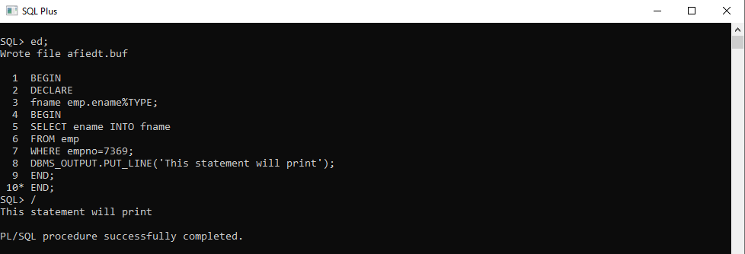

3.6: Write a PL/SQL program to check for the commission for an employee no 7369. If no

commission exists, then display the error message. Use Exceptions.

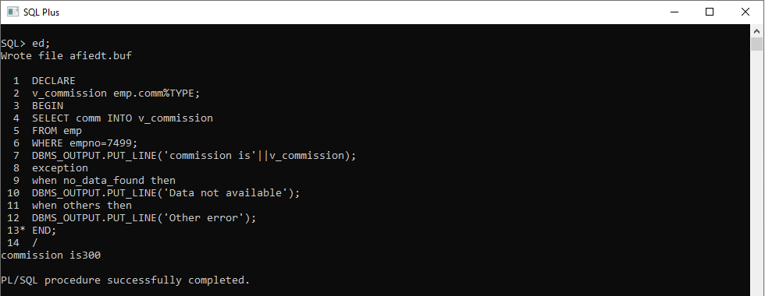

3.7: Write a PL/SQL block to drop any user defined table.

